Assignment 13.
1.What is Index? (Index saved in database like “database name~index name”)
->An Index is a database object that improves the speed of data retrieval from a database table.
It helps the system find records faster, without scanning the entire table.
*Why Index is Used
To increase SELECT query performance
To reduce full table scans
To retrieve data quickly using WHERE conditions
Without index → SAP scans all records
With index→SAP directly jumps to matching records
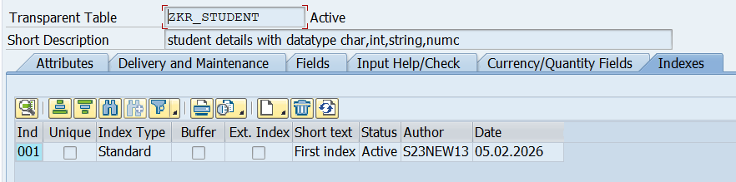

Types of Index:
1.Primary Index:
Automatically created when a primary key is defined
Based on primary key fields
Stored on the database level
Always exists for a table

2.Secondary Index:
Created manually in SE11
Used for non-primary key fields
Improves performance for frequently used SELECT conditions

3.Extension Index
An extension index is a secondary index created on append structure fields of a standard SAP table to improve performance without modifying the original table.
It is mainly used when customers want to improve performance on additional fields added to a standard SAP table.

What is primary & secondary index?
*Primary Index:
A primary index is automatically created by SAP when a database table is activated.
It is based on the primary key fields of the table and ensures uniqueness of records.
The database uses the primary index to quickly access data using the primary key.
*Secondary Index:
A secondary index is created manually by the developer on non-key fields of a table.
It is used to improve performance when SELECT queries frequently use fields other than the primary key.

2.Difference Between Primary Index and Secondary Index:
Primary Index:
Created automatically
Based on primary key fields
Only one per table
Ensures unique records
Created during table activation

Secondary Index:
Created manually
Based on non-key fields
Multiple allowed
Does not ensure uniqueness
Created when needed for performance

3.Difference between index & extension index.
Index
An index (secondary index) is created on a database table to improve the performance of data retrieval.
It is created on one or more table fields (usually non-primary key fields) that are frequently used in SELECT statements.
Indexes can be created on custom tables and standard SAP tables (only on existing fields).
Extension Index
An extension index is a special type of index created on fields added through an append structure to a standard SAP table.
It is used when we cannot modify the original SAP table but still want to improve performance on custom fields.

Index:
Created on original table fields
Used for custom and standard tables
Created on non-key fields
Does not require append structure
Normal secondary index

Extension Index:
Created on append structure fields
Used only for standard tables with append
Created on customer-added fields
Requires append structure
Special secondary index

4.What's the use of index?
The main use of an index is to speed up data retrieval from a database table.
When a SELECT query is executed, the database uses the index to locate records quickly instead of scanning the entire table.

*Why Index Is Important:
Without an index, the database performs a full table scan, which is slow.
With an index, the database directly accesses the required rows, improving performance and response time.

(An index is used to improve database performance by allowing faster access to records based on specific fields.)

5.What are the disadvantages of index?
Uses additional storage space in the database.
Database stores index data separately from the table.
Indexes can also slow down INSERT, UPDATE, and DELETE operations, because whenever table data changes
overall system performance can decrease instead of improving

6.Do R&D in index option part?
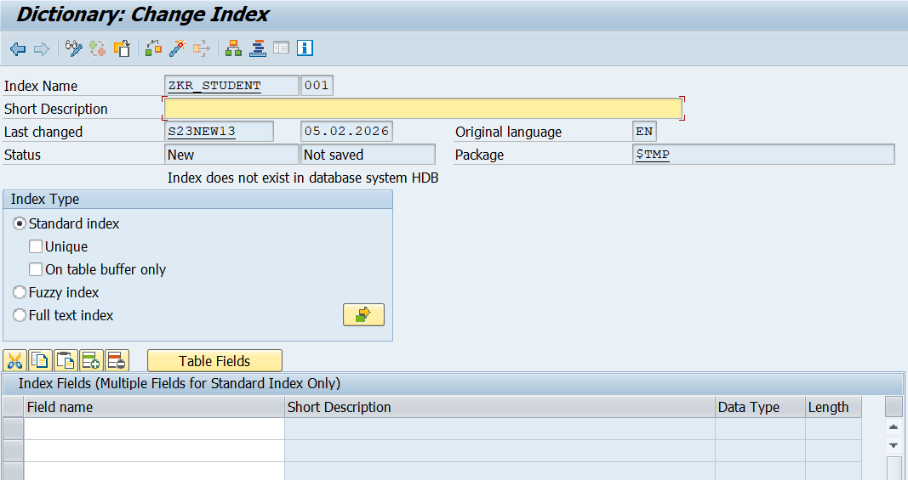

Index Name
This is the name of the index.
Example: ZKR_STUDENT
The number 001 indicates it is a secondary index (primary index is always 0).

Short Description
Used to describe the purpose of the index, such as
“Index for fast student search by department”.

Last changed: User and date
Original language: Language of creation (EN)
Package: Transport package ($TMP means local object)

Status
Shows the current state of the index:
New → created but not yet activated
After activation → exists in database

Index Type Section
Standard Index:
Used for normal database performance improvement.
Most commonly used index type.

Unique (checkbox):
If selected, the index does not allow duplicate values for the indexed fields.

On table buffer only:
Index is used only for buffered tables (rarely used).

Fuzzy Index:
Used for approximate searches, mainly in HANA
Example: search with spelling mistakes.

Full Text Index:
Used for text search on large text fields (like descriptions).

Index Fields Section
Here we can create multiple Indexes.

